Mobile Adhoc Network

Assignment 2

S Abhishek

AM.EN.U4CSE19147

**1 - Explain any two table driven routing protocols in adhoc network with example.**

Destination-Sequenced Distance Vector Routing (DSDV)

* Destination Sequenced Distance Vector Routing protocol is a modified version of **Bellman Ford Algorithm** and is based upon the concepts of **Distance Vector Routing** which uses bidirectional links.
* In Distance Vector Routing (DVR), each node broadcasts a table containing its distance from nodes which are directly connected and based upon this, other nodes broadcast the updated routing.
* DSDV is based on the **Routing Information Protocol (RIP)** where a node holds a routing table containing all the possible destinations within the network and the number of hops to each destination.
* Updates are performed on a regular basis, and are instantly scheduled if a new event is detected in the topology.
* Tables are updated in the topology per exchange between nodes and each node **periodically** sends updates tagged throughout the network with a monotonically **increasing even sequence number** to advertise its location.
* New route broadcasts contains,
  + Address of the destination,
  + Number of hops to reach the destination
  + Sequence number of the information received regarding the destination and,
  + New sequence number unique to the broadcast.
* Every node stores the **next routing hop** for every reachable destination in their routing table.
* Nodes who receive this data can then update their tables if they received a better route, or a new one.
* Those nodes which are unreachable directly are labelled as **infinite**.
* Each DSDV node maintains two routing tables,
  + One for forwarding packets
  + One for advertising incremental routing packets
* When this updation of routing tables keeps on happening, an **infinite loop** is generated which is commonly known as **Count-To-Infinity problem**.
* To overcome this problem of count to infinity by generating sequence number in the routing table, every time the routing table is updated.
* If there are frequent changes in topology, full table exchange will be preferred whereas in a stable topology, incremental updates will cause less traffic.
* Routing table updates in DSDV are distributed by two different types of update packets,
* **Full dump** 
  + This type of update packet contains all the routing information available at a node and full dump packets are transmitted infrequently if the node only experiences occasional movement.
* **Incremental**
  + This type of update packet contains only the information that has changed since the latest full dump was sent out by the node.
  + Hence, incremental packets only consume a fraction of the network resources compared to a full dump.
* The route selection is performed on the **metric** and **sequence number** criteria.
* The sequence number is a **time indication** sent by the destination node.
* It allows the table update process, as if two identical routes are known, the one with the best sequence number is kept and used, while the other is destroyed (considered as a stale entry).
* On receipt of an update packet from a neighbouring node, a node extracts the information from the packet and updates its routing table based on the Algorithm.

**Algorithm**

1. If the new address has a higher sequence number, the node chooses the route with the higher sequence number and discards the old sequence number.
2. If the incoming sequence number is identical to the one belonging to the existing route, a route with the least cost is chosen.
3. All the metrics chosen from the new routing information are incremented.
4. This process continues until all the nodes are updated.
5. If there are duplicate updated packets, the node considers keeping the one with the least-cost metric and discards the rest.
6. In case of a broken link, a cost of metric with a new sequence number (incremented) is assigned to it to ensure that the sequence number of that metric is always greater than or equal to the sequence number of that node.

* A limitation of DSDV is that it provides only one route for a source/destination pair.

**Example**

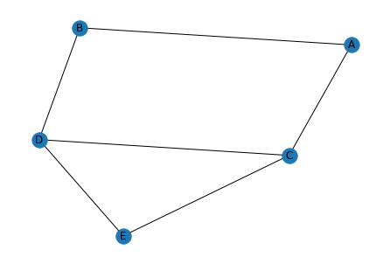

**Routing Table of A**

|  |  |  |  |
| --- | --- | --- | --- |
| **Destination** | **Next Hop** | **Distance** | **Sequence No** |
| B | B | 1 | A1 |
| C | C | 1 | A2 |
| D | B | 2 | A3 |
| E | C | 2 | A4 |

**After changing the position of D**

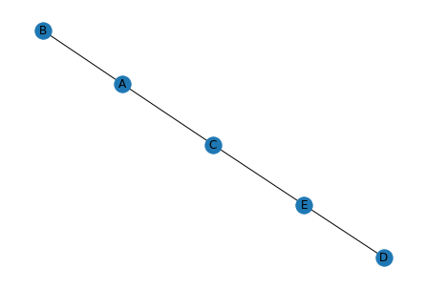

**Updated Routing Table of A**

|  |  |  |  |
| --- | --- | --- | --- |
| **Destination** | **Next Hop** | **Distance** | **Sequence No** |
| B | B | 1 | A1 |
| C | C | 1 | A2 |
| E | C | 2 | A4 |
| D | C | 3 | A5 |

Cluster-head Gateway Switch Routing - CGSR

* CGSR routing involves cluster routing, whereby a node is required to find the best route over cluster heads from the cluster-member table.
* The cluster-head gateway switch routing (CGSR) is a hierarchical routing protocol.
* It is a proactive protocol where when a source routes the packets to destination, the routing tables will be already available at the nodes.
* A cluster higher in hierarchy sends the packets to the cluster lower in hierarchy.
* CGSR forms a cluster structure where the nodes are aggregated into clusters and a cluster-head is elected.
* In a dynamic network cluster head scheme can cause performance degradation due to frequent cluster-head elections.
* So CGSR uses a Least Cluster Change (LCC) algorithm.
* In LCC, cluster-head change occurs only if a change in network causes two cluster-heads to come into one cluster or one of the nodes moves out of the range of all the cluster-heads.
* The nodes aggregate into clusters using an appropriate algorithm which defines three types of nodes.
* Internal nodes
  + Internal nodes transmit and receive the messages and packets through a cluster-head
  + All internal nodes that are in the communication range of the cluster-head belong to its cluster.
* Cluster-head
  + Cluster-head in each cluster dynamically schedules the route paths.
  + It controls a group of ad-hoc hosts, monitors broadcasting within the cluster, and forwards the messages to another cluster-head.
* Gateway node
  + A gateway node is a node that is in the communication range of two or more cluster-heads
  + Gateway nodes carry out transmission and reception of messages and packets between cluster-heads of two clusters.
* The cluster structure leads to a higher performance of the routing protocol as compared to other protocols because it provides gateway switch-type traffic redirections and clusters provide an effective membership of nodes for connectivity.

**Algorithm**

* Periodically, every node sends a hello message containing its ID and a monotonically increasing sequence number.
* Using these messages, every cluster-head maintains a table containing the IDs of nodes belonging to it and their most recent sequence numbers.
* Cluster-heads exchange these tables with each other through gateways;
* Eventually, each node will have an entry in the affiliation table of each cluster-head.
* This entry shows the node’s ID & cluster-head of that node.
* Each cluster-head and each gateway maintain a routing table with an entry for every cluster-head that shows the next gateway on the shortest path to that cluster head.
* Nodes within each cluster route their packets to their own associated clusters.
* The transmitting node then sends its packet to the next hop, according to the routing table entry associated with that cluster head.
* The cluster head transmits the packet to another cluster head until the cluster head of the destination node is reached.

**Example :** Routing in an area in which has six clusters.

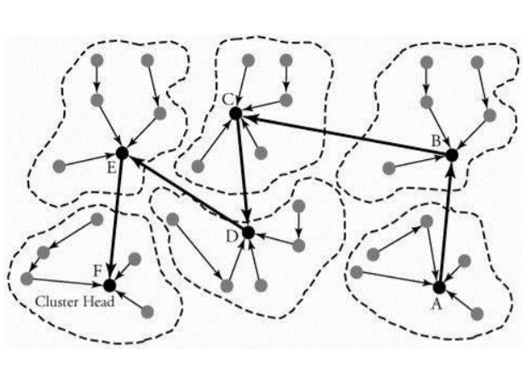

* A node in cluster A is transmitting a packet to a node in cluster F.
* The routing is made through a series of available cluster heads from A to F.

Thankyou!!